**Practical – 1**

**AIM:** .NET Framework and Architecture

**Practical – 2**

**AIM:** **Practical to use windows form (e.g. using form make a Calculator)**

Public Class Calculator

Dim Total As Single

Dim strSign As String

Private Sub btnOne_Click(ByVal sender As System.Object, ByVal e As System.EventArgs) Handles btnOne.Click

txtDisplay.Text = txtDisplay.Text + btnOne.Text

End Sub

Private Sub btnTwo_Click(ByVal sender As System.Object, ByVal e As System.EventArgs) Handles btnTwo.Click

txtDisplay.Text = txtDisplay.Text + btnTwo.Text

End Sub

Private Sub btnThree_Click(ByVal sender As System.Object, ByVal e As System.EventArgs) Handles btnThree.Click

txtDisplay.Text = txtDisplay.Text + btnThree.Text

End Sub

Private Sub btnFour_Click (ByVal sender As System.Object, ByVal e As System.EventArgs) Handles btnFour.Click

txtDisplay.Text = txtDisplay.Text + btnFour.Text()

End Sub

Private Sub btnFive_Click(ByVal sender As System.Object, ByVal e As System.EventArgs) Handles btnFive.Click

txtDisplay.Text = txtDisplay.Text + btnFive.Text

End Sub

Private Sub btnSix_Click(ByVal sender As System.Object, ByVal e As System.EventArgs) Handles btnSix.Click

txtDisplay.Text = txtDisplay.Text + btnSix.Text

End Sub

Private Sub btnSeven_Click(ByVal sender As System.Object, ByVal e As System.EventArgs) Handles btnSeven.Click

txtDisplay.Text = txtDisplay.Text + btnSeven.Text

End Sub

Private Sub btnEight_Click(ByVal sender As System.Object, ByVal e As System.EventArgs) Handles btnEight.Click

txtDisplay.Text = txtDisplay.Text + btnEight.Text

End Sub

Private Sub btnNine_Click(ByVal sender As System.Object, ByVal e As System.EventArgs) Handles btnNine.Click

txtDisplay.Text = txtDisplay.Text + btnNine.Text

End Sub

Private Sub btnZero_Click(ByVal sender As System.Object, ByVal e As System.EventArgs) Handles btnZero.Click

txtDisplay.Text = txtDisplay.Text + btnZero.Text

End Sub

Private Sub btnDot_Click(ByVal sender As System.Object, ByVal e As System.EventArgs) Handles btnDot.Click

If InStr(txtDisplay.Text, ".") > 0 Then

Exit Sub

Else

txtDisplay.Text = txtDisplay.Text + btnDot.Text

End If

End Sub

Private Sub btnClear_Click(ByVal sender As System.Object, ByVal e As System.EventArgs) Handles btnClear.Click

txtDisplay.Text = ""

Total = 0

End Sub

Private Sub btnPlus_Click(ByVal sender As System.Object, ByVal e As System.EventArgs) Handles btnPlus.Click

Total = Total + Val(txtDisplay.Text)

txtDisplay.Clear()

strSign = "plus"

End Sub

Private Sub btnMinus_Click(ByVal sender As System.Object, ByVal e As System.EventArgs) Handles btnMinus.Click

Total = Total + Val(txtDisplay.Text)

txtDisplay.Clear()

strSign = "minus"

End Sub

Private Sub btnMul_Click(ByVal sender As System.Object, ByVal e As System.EventArgs) Handles btnMul.Click

Total = Total + Val(txtDisplay.Text)

txtDisplay.Clear()

strSign = "mul"

End Sub

Private Sub btnDivide_Click(ByVal sender As System.Object, ByVal e As System.EventArgs) Handles btnDivide.Click

Total = Total + Val(txtDisplay.Text)

txtDisplay.Clear()

strSign = "divide"

End Sub

Private Sub btnEqual_Click(ByVal sender As System.Object, ByVal e As System.EventArgs) Handles btnEqual.Click

If (strSign.ToString().Trim().ToLower() = "plus") Then

txtDisplay.Text = Total + Convert.ToDecimal(txtDisplay.Text)

Total = 0

ElseIf (strSign.ToString().Trim().ToLower() = "minus") Then

txtDisplay.Text = Total - Convert.ToDecimal(txtDisplay.Text)

Total = 0

ElseIf (strSign.ToString().Trim().ToLower() = "mul") Then

txtDisplay.Text = Total * Convert.ToDecimal(txtDisplay.Text)

Total = 0

ElseIf (strSign.ToString().Trim().ToLower() = "divide") Then

Dim totaltemp As Single

Try

totaltemp = Total / Convert.ToDecimal(txtDisplay.Text)

Dim Temp As String = totaltemp.ToString()

If (Temp.ToString() = "Infinity") Then

txtDisplay.Text = ""

MessageBox.Show("You can not divide any value by zero", "Error...")

Else

txtDisplay.Text = totaltemp

End If

Catch ex As Exception

End Try

Total = 0

End Sub

Private Sub btnPlusMinus_Click(ByVal sender As System.Object, ByVal e As System.EventArgs) Handles btnPlusMinus.Click

If (txtDisplay.Text <> "") Then

txtDisplay.Text = -1 * Val(txtDisplay.Text)

End If

End Sub

End Class

**OUTPUT:**

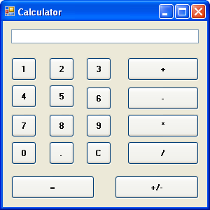

**Practical – 3**

**AIM:Write a program to create a form using window application**

Public Class Form1

Private Sub Button2_Click(ByVal sender As System.Object, ByVal e As System.EventArgs) Handles btn_reset.Click

txt_nam.Text = ""

txt_add.Text = ""

txt_phn.Text = ""

rdb_male.Checked = "FALSE"

rdb_female.Checked = "FALSE"

chk_play.Checked = False

chk_music.Checked = False

chk_travel.Checked = False

cb_select.Text = ""

End Sub

Private Sub Button1_Click(ByVal sender As System.Object, ByVal e As System.EventArgs) Handles btn_submit.Click

listbox.Show()

listbox.Text = listbox.Items.Add(lbl_name.Text + txt_nam.Text)

listbox.Text = listbox.Items.Add(lbl_add.Text + txt_add.Text)

listbox.Text = listbox.Items.Add(lbl_phn.Text + txt_phn.Text)

If (rdb_male.Checked = True) Then

listbox.Text = listbox.Items.Add(lbl_gen.Text + rdb_male.Text)

Else

listbox.Text = listbox.Items.Add(lbl_gen.Text + rdb_female.Text)

End If

If (chk_play.Checked = True And chk_music.Checked = True And chk_travel.Checked = True) Then

listbox.Text = listbox.Items.Add(lbl_hob.Text + chk_play.Text + " AND " + chk_travel.Text + " AND " + chk_music.Text)

End If

If (chk_play.Checked = True And chk_music.Checked = True) Then

listbox.Text = listbox.Items.Add(lbl_hob.Text + chk_play.Text + " AND " + chk_music.Text)

End If

If (chk_play.Checked = True And chk_travel.Checked = True) Then

listbox.Text = listbox.Items.Add(lbl_hob.Text + chk_play.Text + " AND " + chk_travel.Text)

End If

If (chk_travel.Checked = True And chk_music.Checked = True) Then

listbox.Text = listbox.Items.Add(lbl_hob.Text + chk_travel.Text + " AND " + chk_music.Text)

End If

listbox.Text = listbox.Items.Add(lbl_con.Text + cb_select.SelectedItem)

End Sub

Private Sub Form1_Load(ByVal sender As System.Object, ByVal e As System.EventArgs) Handles MyBase.Load

listbox.Hide()

End Sub

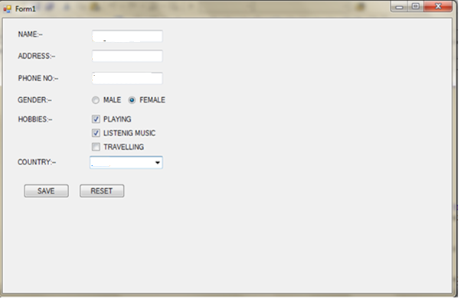

**Practical – 4**

**AIM: Implement oops fundamental with vb.net(Inheritance)**

Public Class Form1

Private Sub btnSubmit_Click(ByVal sender As System.Object, ByVal e As System.EventArgs) Handles btnSubmit.Click

lstData.Items.Clear() Dim obj1 = New student(txtName.Text) obj1.mrk1 = txtMarks1.Text obj1.mrk2 = txtMarks2.Text

lblAverage.Text = "Average : " & (Convert.ToDecimal(txtMarks1.Text) + Convert.ToDecimal(txtMarks2.Text)) / 2

lstData.Items.Add(obj1.retname()) lstData.Items.Add(obj1.mrk1()) lstData.Items.Add(obj1.mrk2())

End Sub End Class

Public Class Marks

Dim m1 As Integer Dim m2 As Integer

Property mrk1() As Integer Get Return m1 End Get Set(ByVal value As Integer) m1 = value End Set End Property

Property mrk2() As Integer Get Return m2 End Get

Set(ByVal value As Integer) m2 = value End Set End Property

End Class

Public Class student Inherits Marks

Dim str As String

Sub New(ByVal val) str = val End Sub

Public Function retname() As String Return str End Function

End Class

**Output :**

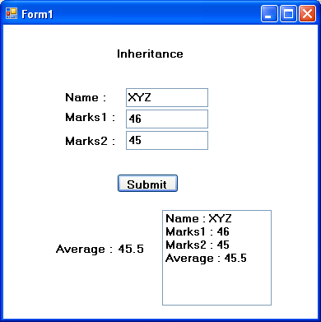

**Practical – 5**

**Aim**: **Implement OOPs Fundamental with VB.NET(Constructor)**

Public Class Form1

Private Sub Label1_Click(ByVal sender As System.Object, ByVal e As System.EventArgs) Handles Label1.Click, label1.Click

End Sub

Private Sub RichTextBox1_TextChanged(ByVal sender As System.Object, ByVal e As System.EventArgs) Handles txt_result.TextChanged

End Sub

Private Sub Button1_Click(ByVal sender As System.Object, ByVal e As System.EventArgs) Handles Button1.Click

Dim obj1 = New Student()

obj1.name = txt_name.Text()

obj1.surname = txt_surname.Text()

If rdo_btn_name.Checked Then

Try

txt_result.Text = obj1.retname(obj1.name)

Catch ex As Exception

MessageBox.Show("please enter correctly.")

End Try

ElseIf rdo_btn_both.Checked Then

txt_result.Text = obj1.retname(obj1.name, obj1.surname)

End If

End Sub

End Class

Public Class Student

Dim fname As String

Dim flname As String

Property name() As String

Get

Return fname

End Get

Set(ByVal value As String)

fname = value

End Set

End Property

Property surname() As String

Get

Return flname

End Get

Set(ByVal value As String)

flname = value

End Set

End Property

Public Function retname(ByVal name As String)

Return fname

End Function

Public Function retname(ByVal name As String, ByVal surname As String)

flname = " " & name + " " & surname

Return flname

End Function

End Class

**OUTPUT:**

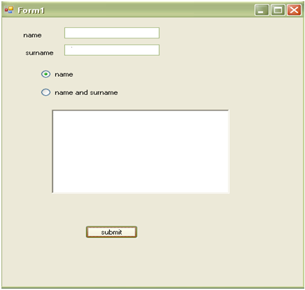

**Practical – 6**

**AIM: Implement oops fundamental with vb.net(Overloading)**

Public Class Form1

Private Sub btnSubmit_Click(ByVal sender As System.Object, ByVal e As System.EventArgs) Handles btnSubmit.Click

If rdAddition.Checked Then

Try

txtAnswer.Text = Convert.ToString(Calculation(Convert.ToDecimal(txtvalue1.Text), Convert.ToDecimal(txtvalue2.Text)))

Catch ex As Exception

MessageBox.Show("please enter correct value for addition.")

End Try

ElseIf rdConcate.Checked Then

txtAnswer.Text = Convert.ToString(Calculation(Convert.ToString(txtvalue1.Text), Convert.ToString(txtvalue2.Text)))

End If

End Sub

Private Overloads Function Calculation(ByVal str1 As String, ByVal str2 As String) As String

Dim str3 As String

str3 = str1 + str2

Return str3

End Function

Private Overloads Function Calculation(ByVal a As Decimal, ByVal b As Decimal) As Decimal

Dim c As Decimal

c = a + b

Return c

End Function

End Class

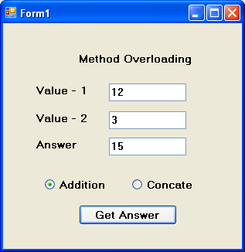

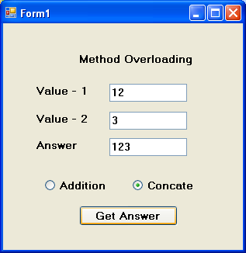

**Practical – 8**

**AIM : Develop console application.**

Module Module1

Sub Main()

Dim a, b, ch As Integer

System.Console.WriteLine("")

System.Console.Write("Enter integer value of a:")

a = System.Console.ReadLine()

System.Console.Write("Enter integer value of b:")

b = System.Console.ReadLine()

System.Console.WriteLine("")

System.Console.WriteLine("1.Addition")

System.Console.WriteLine("2.Subtraction")

System.Console.WriteLine("3.Multiplication")

System.Console.WriteLine("4.Division")

System.Console.WriteLine("")

System.Console.Write("Enter your choice:")

ch = System.Console.ReadLine()

Select Case ch

Case 1

System.Console.WriteLine(a + b)

Case 2

System.Console.WriteLine(a - b)

Case 3

System.Console.WriteLine(a * b)

Case 4

System.Console.WriteLine(a / b)

Case Else

System.Console.WriteLine("Enter correct choice.")

End Select

Console.Read()

End Sub

End Module

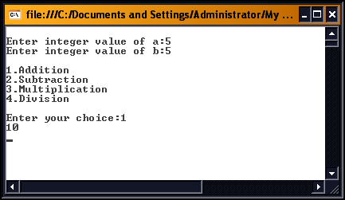

**Practical – 9**

**AIM : Develop application to connect webpage to database using ADO.NET**

**MyMaster.master**

<%@ Master Language="C#" AutoEventWireup="true" CodeFile="MyMaster.master.cs" Inherits="MyMaster" %>

<!DOCTYPE html PUBLIC "-//W3C//DTD XHTML 1.0 Transitional//EN" "http://www.w3.org/TR/xhtml1/DTD/xhtml1-transitional.dtd">

<html xmlns="http://www.w3.org/1999/xhtml">

<head runat="server">

<title></title>

<asp:ContentPlaceHolder ID="head" runat="server">

</asp:ContentPlaceHolder>

</head>

<body>

<form id="form1" runat="server">

<table style="border: 1px solid #ADB9CD; font-family: Arial,Helvetica,sans-serif;"

cellpadding="2" cellspacing="0" width="100%">

<tr> <td align="center" style="color: #fff; font-size: 26px; background-color: #ADB9CD;">

ADO Demo </td> </tr>

<tr> <td> <asp:ContentPlaceHolder ID="ContentPlaceHolder1" runat="server">

</asp:ContentPlaceHolder> </td> </tr>

</table>

</form>

</body>

</html>

**Default.aspx**

<%@ Page Title="" Language="C#" MasterPageFile="~/MyMaster.master" AutoEventWireup="true" CodeFile="Default.aspx.cs" Inherits="_Default" %>

<asp:Content ID="Content1" ContentPlaceHolderID="head" runat="Server"> </asp:Content>

<asp:Content ID="Content2" ContentPlaceHolderID="ContentPlaceHolder1" runat="Server">

<div> <table align="center">

<tr> <td colspan="2" align="center"> <asp:Label ID="hdr" runat="server" Text="Student Information" Font-Bold="true" Font-Underline="true" Font-Size="X- arge"></asp:Label> </td> </tr>

<tr> <td> <asp:Label ID="lblStudentID" runat="server" Text="Student ID:"> </asp:Label> </td>

<td align="center"> <asp:TextBox ID="txtStudentID" runat="server"> </asp:TextBox> </td> </tr>

<tr> <td> <asp:Label ID="lblStudentName" runat="server" Text="Student Name:"> </asp:Label> </td>

<td align="center"> <asp:TextBox ID="txtStudentName" runat="server"> </asp:TextBox> </td> </tr>

<tr> <td> <asp:Label ID="lblStudentContactNum" runat="server" Text="Student Contact Number:"></asp:Label> </td>

<td align="center"> <asp:TextBox ID="txtStudentContactNum" runat="server"> </asp:TextBox> </td> </tr>

<tr> <td> <asp:Label ID="lblStudentAddress" runat="server" Text="Student Address:"> </asp:Label> </td>

<td align="center"> <asp:TextBox ID="txtStudentAddress" runat="server"> </asp:TextBox> </td> </tr>

<tr> <td colspan="2" align="center" style="height:40px;"> <asp:Button ID="btnInsert" runat="server" Text="Insert" OnClick="btnInsert_Click" /> &nbsp;

<asp:Button ID="btnUpdate" runat="server" Text="Update" OnClick="btnUpdate_Click" /> &nbsp;

<asp:Button ID="btnDelete" runat="server" Text="Delete" OnClick="btnDelete_Click" /> &nbsp;

<asp:Button ID="btnSelect" runat="server" Text="Select" OnClick="btnSelect_Click" />&nbsp;

<asp:Button ID="btnRefresh" runat="server" Text="Refresh" OnClick="btnRefresh_Click" /> </td> </tr>

<tr> <td align="center"> <asp:Label ID="lbl5" runat="server" Text=""></asp:Label>

</td> </tr>

<tr> <td colspan="2" align="center">

<asp:GridView ID="GridView1" runat="server" AutoGenerateColumns="true" CellPadding="4"

ForeColor="#333333" GridLines="None">

<AlternatingRowStyle BackColor="White" ForeColor="#284775" />

<EditRowStyle BackColor="#999999" />

<FooterStyle BackColor="#5D7B9D" Font-Bold="True" ForeColor="White" />

<HeaderStyle BackColor="#5D7B9D" Font-Bold="True" ForeColor="White" />

<PagerStyle BackColor="#284775" ForeColor="White" HorizontalAlign="Center" />

<RowStyle BackColor="#F7F6F3" ForeColor="#333333" />

<SelectedRowStyle BackColor="#E2DED6" Font-Bold="True" ForeColor="#333333" />

<SortedAscendingCellStyle BackColor="#E9E7E2" />

<SortedAscendingHeaderStyle BackColor="#506C8C" />

<SortedDescendingCellStyle BackColor="#FFFDF8" />

<SortedDescendingHeaderStyle BackColor="#6F8DAE" />

</asp:GridView> </td> </tr>

</table> </div>

</asp:Content>

**Default.cs**

using System;

using System.Collections.Generic;

using System.Linq;

using System.Web;

using System.Web.UI;

using System.Web.UI.WebControls;

using System.Data.SqlClient;

using System.Data;

using System.Configuration;

public partial class _Default : System.Web.UI.Page

{

protected void Page_Load(object sender, EventArgs e)

{

if (!IsPostBack)

{

FillStudents();

}

}

protected void btnInsert_Click(object sender, EventArgs e)

{

string cs = ConfigurationManager.ConnectionStrings["DBCon"].ConnectionString;

SqlConnection conn = new SqlConnection(cs);

if (conn.State == ConnectionState.Closed)

{

conn.Open();

}

string str;

str = "insert into Students values('" + txtStudentName.Text + "','" + txtStudentContactNum.Text + "','" + txtStudentAddress.Text + "')";

SqlCommand cmd = new SqlCommand(str, conn);

cmd.ExecuteNonQuery();

txtStudentID.Text = "";

txtStudentName.Text = "";

txtStudentContactNum.Text = "";

txtStudentAddress.Text = "";

lbl5.Text = "Recorded Successfully";

FillStudents();

}

public SqlConnection Getconnection()

{

string cs = ConfigurationManager.ConnectionStrings["DBCon"].ConnectionString;

SqlConnection conn = new SqlConnection(cs);

if (conn.State == ConnectionState.Open)

{

conn.Close();

}

return conn;

}

protected void btnUpdate_Click(object sender, EventArgs e)

{

//string cs = ConfigurationManager.ConnectionStrings["DBCon"].ConnectionString;

//SqlConnection conn = new SqlConnection(cs);

//if (conn.State == ConnectionState.Open)

//{

// conn.Close();

//}

SqlConnection conn = Getconnection();

conn.Open();

string str = "";

str = "Update Students Set Name='" + txtStudentName.Text.ToString().Trim() + "',ContactNumber=" + convert.ToInt32(txtStudentContactNum.Text.ToString().Trim() ) + ",Address='" + txtStudentAddress.Text.ToString().Trim() + "' where SID=" + Convert.ToInt32(txtStudentID.Text.ToString().Trim());

SqlCommand cmd = new SqlCommand(str, conn);

cmd.ExecuteNonQuery();

FillStudents();

lbl5.Text = "Updated Successfully";

txtStudentID.Text = "";

txtStudentName.Text = "";

txtStudentContactNum.Text = "";

txtStudentAddress.Text = "";

}

protected void btnSelect_Click(object sender, EventArgs e)

{

string cs = ConfigurationManager.ConnectionStrings["DBCon"].ConnectionString;

SqlConnection conn = new SqlConnection(cs);

if (conn.State == ConnectionState.Closed)

{

conn.Open();

}

string str;

SqlDataReader rdr;

str = "Select * from Students where SID='" + txtStudentID.Text + "'";

SqlCommand cmd = new SqlCommand(str, conn);

rdr = cmd.ExecuteReader();

while (rdr.Read())

{

txtStudentID.Text = Convert.ToString(rdr["SID"]);

txtStudentName.Text = Convert.ToString(rdr["Name"]);

txtStudentContactNum.Text = Convert.ToString(rdr["ContactNumber"]);

txtStudentAddress.Text = Convert.ToString(rdr["Address"]);

}

}

protected void btnDelete_Click(object sender, EventArgs e)

{

string cs = ConfigurationManager.ConnectionStrings["DBCon"].ConnectionString;

SqlConnection conn = new SqlConnection(cs);

if (conn.State == ConnectionState.Closed)

{

conn.Open();

}

string str;

str = "delete from Students where SID='" + txtStudentID.Text + "'";

SqlCommand cmd = new SqlCommand(str, conn);

cmd.ExecuteNonQuery();

lbl5.Text = "Deleted Successfully";

FillStudents();

}

protected void btnRefresh_Click(object sender, EventArgs e)

{

txtStudentID.Text = "";

txtStudentName.Text = "";

txtStudentContactNum.Text = "";

txtStudentAddress.Text = "";

lbl5.Text = "";

}

public void FillStudents()

{

string cs = ConfigurationManager.ConnectionStrings["DBCon"].ConnectionString;

SqlConnection conn = new SqlConnection(cs);

if (conn.State == ConnectionState.Closed)

{

conn.Open();

}

string str;

str = "Select * from Students";

SqlCommand cmd = new SqlCommand(str, conn);

SqlDataAdapter adp = new SqlDataAdapter();

DataTable dt = new DataTable();

adp.SelectCommand = cmd;

adp.Fill(dt);

if (dt != null && dt.Rows.Count > 0)

{

GridView1.DataSource = dt;

GridView1.DataBind();

}

else

{

GridView1.DataSource = null;

GridView1.DataBind();

}

}

}

**Web.config**

<?xml version="1.0"?>

<!--

For more information on how to configure your ASP.NET application, please visit

http://go.microsoft.com/fwlink/?LinkId=169433

-->

<configuration>

<system.web>

<compilation debug="true" targetFramework="4.0"/>

</system.web>

<connectionStrings>

<add name="DBCon" connectionString="Data Source=.\SQLEXPRESS;AttachDbFilename = |DataDirectory|\StudentDB.mdf;Integrated Security=True;User Instance=True"/>

</connectionStrings>

</configuration>

**Practical-10**

**Aim**: **Develop an asp.net web application to demonstrate session management across application.**

LoginPage.axps.cs:

using System;

using System.Collections.Generic;

using System.Linq;

using System.Web;

using System.Web.UI;

using System.Web.UI.WebControls;

public partial class LoginPage : System.Web.UI.Page

{ protected void Page_Load(object sender, EventArgs e)

{ }

protected void btnLogin_Click(object sender, EventArgs e)

{

Session["UserName"] = txtUName.Text;

Session["Password"] = txtPassword.Text;

Response.Redirect("Welcome.aspx");

}

}

Welcome.aspx.cs:

using System;

using System.Collections.Generic;

using System.Linq;

using System.Web;

using System.Web.UI;

using System.Web.UI.WebControls;

public partial class Welcome : System.Web.UI.Page

{

protected void Page_Load(object sender, EventArgs e)

{

if (Session.Count == 0)

{

Response.Redirect("LoginPage.aspx");

}

if (!IsPostBack)

{

if (Session["UserName"] != null)

{

lblNote.Text = Convert.ToString(Session["UserName"]);

}

}

}

protected void btnLogout_Click(object sender, EventArgs e)

{

Session.Clear();

Session.Abandon();

Response.Redirect("LoginPage.aspx");

}

}

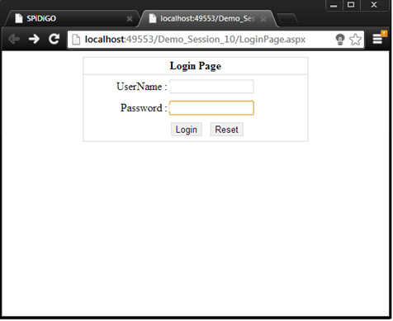

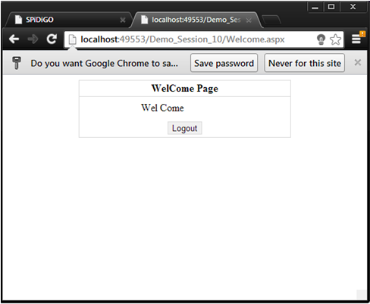

**Practical – 12**

**AIM : Develop ASP.NET application to demonstrate Data bound control**

**RepeaterDemo.aspx**

<%@ Page Title="" Language="C#" MasterPageFile="~/MyMaster.master" AutoEventWireup="true"

CodeFile="RepeaterDemo.aspx.cs" Inherits="RepeaterDemo" %>

<asp:Content ID="Content1" ContentPlaceHolderID="head" runat="Server">

</asp:Content>

<asp:Content ID="Content2" ContentPlaceHolderID="ContentPlaceHolder1" runat="Server">

<style type="text/css">

body

{

font-size: 13px;

}

th

{

background-color: #aaa;

color: #fff;

font-size: 14px;

text-align: center;

}

..rpt

{

border: 1px solid #dadada;

}

</style>

<div>

<table align="center" width="40%">

<tr>

<td colspan="2" align="center">

<asp:Label ID="hdr" runat="server" Text="Student Information" Font-Bold="true" Font-Underline="true"

Font-Size="16px"></asp:Label>

</td>

</tr>

<tr>

<td colspan="2" align="center">

<asp:Label ID="lbl5" runat="server" ForeColor="Red"></asp:Label>

</td>

</tr>

<tr>

<td>

<asp:Label ID="lblStudentName" runat="server" Text="Student Name:"></asp:Label>

</td>

<td align="center">

<asp:TextBox ID="txtStudentName" runat="server"></asp:TextBox>

</td>

</tr>

<tr>

<td>

<asp:Label ID="lblStudentContactNum" runat="server" Text="Student Contact Number:"></asp:Label>

</td>

<td align="center">

<asp:TextBox ID="txtStudentContactNum" runat="server"></asp:TextBox>

</td>

</tr>

<tr>

<td>

<asp:Label ID="Label1" runat="server" Text="Gender:"></asp:Label>

</td>

<td align="center">

<asp:RadioButtonList ID="rblGender" RepeatColumns="4" RepeatDirection="Horizontal"

runat="server">

</asp:RadioButtonList>

</td>

</tr>

<tr>

<td>

<asp:Label ID="lblStudentAddress" runat="server" Text="Student Address:"></asp:Label>

</td>

<td align="center">

<asp:TextBox ID="txtStudentAddress" runat="server"></asp:TextBox>

</td>

</tr>

<tr>

<td colspan="2" align="center" style="height: 40px;">

<asp:Button ID="btnInsert" runat="server" Text="Insert" OnClick="btnInsert_Click" />&nbsp;

<asp:Button ID="btnCancel" runat="server" Text="Reset" OnClick="btnCancel_Click" />

</td>

</tr>

<tr>

<td colspan="2">

&nbsp;

</td>

</tr>

</table>

<table cellpadding="0" cellspacing="0" width="60%" align="center">

<tr>

<td>

<asp:Repeater ID="rptStudent" runat="server" OnItemCommand="rptStudent_ItemCommand">

<HeaderTemplate>

<table cellpadding="4" cellspacing="0" width="100%" class="rpt">

<tr>

<th> StudentID </th>

<th> Name </th>

<th> Contact no. </th>

<th> Gender </th>

<th> Address </th>

<th align="center"> Edit </th>

<th align="center"> Delete </th> </tr>

</HeaderTemplate>

<ItemTemplate>

<tr>

<td align="center">

<asp:Label ID="lblSrno" runat="server" Text='<%# Eval("SID") %>'></asp:Label></td>

<td align="center">

<asp:Label ID="lblName" runat="server" Text='<%# Eval("SName") %>'></asp:Label></td>

<td align="center">

<asp:Label ID="lblcontactNo" runat="server" Text='<%# Eval("SContact") %>'></asp:Label>

</td>

<td align="center">

<asp:Label ID="lblGender" runat="server" Text='<%# Eval("SGender") %>'> </asp:Label></

<td align="center">

<asp:Label ID="lblAddress" runat="server" Text='<%# Eval("SAddress") %>'>

</asp:Label> </td>

<td align="center">

<asp:LinkButton ID="lnkEdit" CommandArgument='<%# Eval("SID") %>' CommandName ="Edit" runat="server">Edit</asp:LinkButton> </td>

<td align="center">

<asp:LinkButton ID="lnkDelete" CommandArgument='<%# Eval("SID") %>' CommandName =" Delete" runat="server" OnClientClick="return confirm('Are you sure want to delete this record?')"> Delete </asp:LinkButton> </td> </tr>

</ItemTemplate>

<FooterTemplate> </table> </FooterTemplate> </asp:Repeater>

<asp:HiddenField ID="hdnSid" Value = "0" runat="server" />

</td> </tr> <tr> <td colspan="2"> <br /> <br />

<asp:DataList ID="dlStudent" runat="server" CellPadding="4" ForeColor="Black" RepeatDirection = "Horizontal" RepeatColumns = 4 BackColor= "#CCCCCC" BorderColor="#999999" BorderStyle="Solid" BorderWidth="3px" CellSpacing="2" GridLines="Both" >

<FooterStyle BackColor="#CCCCCC" />

<HeaderStyle BackColor="Black" Font-Bold="True" ForeColor="White" />

<HeaderTemplate>

Students List

</HeaderTemplate>

<ItemStyle BackColor="White" />

<ItemTemplate>

<table border="0" cellpadding="2" cellspacing="0">

<tr> <td colspan="2"> Student Information </td> </tr>

<tr> <td> ID </td>

<td> <asp:Label ID="lblSrno" runat="server" Text='<%# Eval("SID") %>'></asp:Label> </td> </tr>

<tr> <td> Name </td>

<td> <asp:Label ID="lblName" runat="server" Text='<%# Eval("SName") %>'></asp:Label> </td> </tr>

<tr> <td> Contact No. </td>

<td> <asp:Label ID="lblcontactNo" runat="server" Text='<%# Eval("SContact") %>'></asp:Label> </td> </tr>

<tr> <td> Gender </td>

<td> <asp:Label ID="lblGender" runat="server" Text='<%# Eval("SGender") %>'></asp:Label> </td> </tr>

<tr> <td> Address </td>

<td> <asp:Label ID="lblAddress" runat="server" Text='<%# Eval("SAddress") %>'></asp:Label> </td> </tr>

</table> </ItemTemplate>

<SelectedItemStyle BackColor="#000099" Font-Bold="True" ForeColor= "White" /> </asp:DataList> </td> </tr> </table> </div>

</asp:Content>

**repeaterDemo.cs**

using System;

using System.Collections.Generic;

using System.Linq;

using System.Web;

using System.Web.UI;

using System.Web.UI.WebControls;

using System.Configuration;

using System.Data.SqlClient;

using System.Data;

public partial class RepeaterDemo : System.Web.UI.Page

{

protected void Page_Load(object sender, EventArgs e)

{

if (!IsPostBack)

{

FillGender();

FillStudents();

}

}

protected void btnInsert_Click(object sender, EventArgs e)

{

SqlConnection conn = GetConnection();

if (conn.State == ConnectionState.Closed)

{

conn.Open();

}

string str;

if (btnInsert.Text.ToString().ToLower() == "insert")

{

str = "insert tb_Student values('" + txtStudentName.Text.Replace("'", "''") + "','" + txtStudentContactNum.Text.Replace("'", "''") + "','" + txtStudentAddress.Text.Replace("'", "''") + "','" + rblGender.SelectedItem.Text.Replace("'", "''") + "')";

SqlCommand cmd = new SqlCommand(str, conn);

cmd.ExecuteNonQuery();

lbl5.Text = "Record Inserted Successfully";

}

else if (btnInsert.Text.ToString().ToLower() == "update")

{

str = "Update tb_Student SET SName='" + txtStudentName.Text.ToString().Replace("'", "''") + "',SContact='" + txtStudentContactNum.Text.Replace("'", "''") + "',SAddress='" + txtStudentAddress.Text.Replace("'", "''") + "',SGender='" + rblGender.SelectedItem.Text.ToString().Replace("'", "''") + "' where sid = "+ Convert .ToInt32 (hdnSid .Value )+" ";

SqlCommand cmd = new SqlCommand(str, conn);

cmd.ExecuteNonQuery();

txtStudentName.Text = "";

txtStudentContactNum.Text = "";

txtStudentAddress.Text = "";

lbl5.Text = "Record Updated Successfully";

}

txtStudentName.Text = "";

txtStudentContactNum.Text = "";

txtStudentAddress.Text = "";

btnInsert.Text = "Insert";

btnCancel.Text = "Reset";

FillStudents();

hdnSid.Value = "0";

}

protected void btnCancel_Click(object sender, EventArgs e)

{

txtStudentName.Text = "";

txtStudentContactNum.Text = "";

txtStudentAddress.Text = "";

btnInsert.Text = "Insert";

btnCancel.Text = "Reset";

lbl5.Text = "";

hdnSid.Value = "0";

}

public void FillStudents()

{

DataTable dt = new DataTable();

dt = GetData("");

if (dt != null && dt.Rows.Count > 0)

{

rptStudent.DataSource = dt;

rptStudent.DataBind();

dlStudent.DataSource = dt;

dlStudent.DataBind();

}

else

{

rptStudent.DataSource = null;

rptStudent.DataBind();

dlStudent.DataSource = null;

dlStudent.DataBind();

}

}

protected void rptStudent_ItemCommand(object source, RepeaterCommandEventArgs e)

{

lbl5.Text = "";

if (e.CommandName.ToString().ToLower() == "edit")

{

DataTable dt = new DataTable();

dt = GetData(" Where tb_Student.SID=" + Convert.ToInt32(e.CommandArgument));

if (dt != null && dt.Rows.Count > 0)

{

txtStudentName.Text = Convert.ToString(dt.Rows[0]["SName"]);

txtStudentContactNum.Text = Convert.ToString(dt.Rows[0]["SContact"]);

txtStudentAddress.Text = Convert.ToString(dt.Rows[0]["SAddress"]);

try

{

rblGender.SelectedValue = Convert.ToString(dt.Rows[0]["SGender"]);

}

catch { }

btnInsert.Text = "Update";

btnCancel.Text = "Cancel";

hdnSid.Value = Convert.ToString(e.CommandArgument);

}

}

else if (e.CommandName.ToString().ToLower() == "delete")

{

SqlConnection conn = GetConnection();

if (conn.State == ConnectionState.Closed)

{

conn.Open();

}

string str;

str = "delete from tb_Student where SID=" + Convert.ToInt32(e.CommandArgument);

SqlCommand cmd = new SqlCommand(str, conn);

cmd.ExecuteNonQuery();

txtStudentName.Text = "";

txtStudentContactNum.Text = "";

txtStudentAddress.Text = "";

btnInsert.Text = "Insert";

btnCancel.Text = "Reset";

lbl5.Text = "Deleted Successfully";

FillStudents();

}

}

private void FillGender()

{

SqlConnection conn = GetConnection();

if (conn.State == ConnectionState.Closed)

{

conn.Open();

}

string str = "Select * from tb_Gender";

SqlCommand cmd = new SqlCommand(str, conn);

SqlDataAdapter adp = new SqlDataAdapter();

DataTable dt = new DataTable();

adp.SelectCommand = cmd;

adp.Fill(dt);

if (dt != null && dt.Rows.Count > 0)

{

rblGender.DataSource = dt;

rblGender.DataTextField = "GenderType";

rblGender.DataValueField = "ID";

rblGender.DataBind();

}

else

{

rblGender.DataSource = null;

rblGender.DataBind();

}

if (rblGender.Items.Count > 0)

{

rblGender.SelectedIndex = 0;

}

}

private DataTable GetData(String sql)

{

SqlConnection conn = GetConnection();

if (conn.State == ConnectionState.Closed)

{

conn.Open();

}

string str = "Select * from tb_Student " + sql;

SqlCommand cmd = new SqlCommand(str, conn);

SqlDataAdapter adp = new SqlDataAdapter();

DataTable dt = new DataTable();

adp.SelectCommand = cmd;

adp.Fill(dt);

return dt;

}

public SqlConnection GetConnection()

{

string cs = ConfigurationManager.ConnectionStrings["DBCon"].ConnectionString;

SqlConnection conn = new SqlConnection(cs);

return conn;

}

}

**Output:**

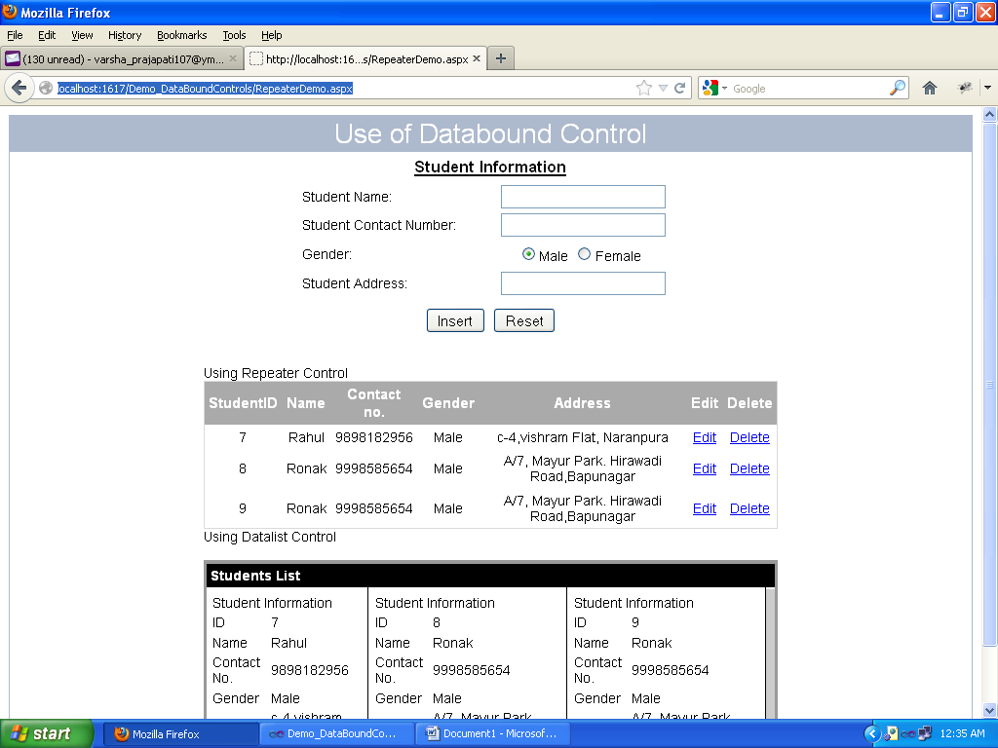

**Practical – 13**

**AIM : Implement Web service**

**AddNumbers.aspx**

<%@ Page Language="C#" AutoEventWireup="true" CodeFile="AddNumbers.aspx.cs" Inherits="AddNumbers" %>

<!DOCTYPE html PUBLIC "-//W3C//DTD XHTML 1.0 Transitional//EN" "http://www.w3.org/TR/xhtml1/DTD/xhtml1-transitional.dtd">

<html xmlns="http://www.w3.org/1999/xhtml">

<head runat="server">

<title></title>

<style type="text/css">

.table

{

border: 1px solid #DADADA;

}

.txtfield

{

border: 1px solid #DADADA;

width: 50px;

}

h1

{

color: #bbb;

}

#lblAnswer

{

border: 1px Solid #DADADA;

}

</style>

</head>

<body>

<form id="form1" runat="server">

<div>

<table class="table" width="50%" cellpadding="2" align="center" cellspacing="0">

<tr>

<td colspan="2" align="center" style="padding: 0px; border-bottom:1px solid #DADADA;">

<h1> Web Service Demo</h1> </td> </tr>

<tr> <td align="right">Number 1 : </td>

<td> <asp:TextBox ID="txtNumber1" runat="server"></asp:TextBox> </td> </tr>

<tr> <td align="right"> Number 2 : </td>

<td> <asp:TextBox ID="txtNumber2" runat="server"></asp:TextBox>/td>

</tr>

<tr><td align="right"> Answer : </td>

<td> <asp:Label ID="lblAnswer" Width="144px" Height="20px" Font-Bold="true" runat="server" Text=""></asp:Label> </td> </tr>

<tr> <td colspan="2" align="center"> <asp:Button ID="btnGetAnswer" runat="server" Text="Get Answer" onclick="btnGetAnswer_Click" /> </td> </tr>

</table> </div> </form> </body> </html>

**AddNumbers.aspx.cs**

using System;

using System.Collections.Generic;

using System.Linq;

using System.Web;

using System.Web.UI;

using System.Web.UI.WebControls;

public partial class AddNumbers : System.Web.UI.Page

{

protected void Page_Load(object sender, EventArgs e)

{ }

protected void btnGetAnswer_Click(object sender, EventArgs e)

{

NumberAddition.Addition add = new NumberAddition.Addition();

Decimal Ans = add.NumberAddition(Convert.ToDecimal(txtNumber1.Text), Convert.ToDecimal(txtNumber2.Text));

lblAnswer.Text = Ans.ToString();

}

}

Webservice File

**Addition.cs**

using System;

using System.Collections.Generic;

using System.Linq;

using System.Web;

using System.Web.Services;

/// <summary>

/// Summary description for Addition

/// </summary>

[WebService(Namespace = "http://tempuri.org/")]

[WebServiceBinding(ConformsTo = WsiProfiles.BasicProfile1_1)]

// To allow this Web Service to be called from script, using ASP.NET AJAX, uncomment the following line.

// [System.Web.Script.Services.ScriptService]

public class Addition : System.Web.Services.WebService

{

public Addition()

{

//Uncomment the following line if using designed components

//InitializeComponent();

}

[WebMethod]

public string HelloWorld()

{

return "Hello World";

}

[WebMethod]

public Decimal NumberAddition(Decimal Num1, Decimal Num2)

{

decimal Num3 = Num1 + Num2;

return Num3;

}

}

**Output**

